Name: _________________________________

Date: __________________

Find x in each figure below.

1. 2.

3. 4.

5. 6.

36°
60°

7. 8.

Find the value of x in each picture using the exterior angle theorem (in most cases).

9. 10.
x
(3x + 30)
62°
x
134°

x = ______ x = ______

11. 12.
(6x – 7)
(103 – x)
2x
80°
x
3x - 22

x = ______ x = ______

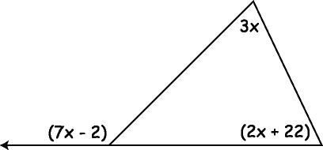
13. 14.
111°
92°

x

x = ______ x = ______

